College: MBM University, Jodhpur

Mathur

Members: Harshita Parsendiya, Priyank Mundel, Gracy

Team Name: Tech Squad

C++ Based Project on Booking Management System

Booking System

SPAPK PROJECT 01 : Travel



• Manage bookings using C++ class

• Store all data in a file (bookings.txt)

• Create, update, and delete bookings

• A basic C++ program that help manage travel bookings.

What This Project is About ?



• All bookings are stored in a file

• - Booking ID

• - Seat Number

• - Destination

• - Phone Number

• - Passenger Name

• Each booking includes:

Project Overview



• Validation for name, age, phone number, destination

• displayAllTabular() - Displays in table format

• seatAvailabilty() - Tells which seat are booked or available

• searchBooking() - Searches bookings by name or place

• cancelBooking() - Cancels a booking using ID

• editBooking() - Lets user change their details

• saveToFile() - Saves booking to a file

• inputDetails() - Takes user inputs and validates it

Key Functions



•Keep running until user selects Exit (8)

•Program uses a do-while loop with menu options

Menu

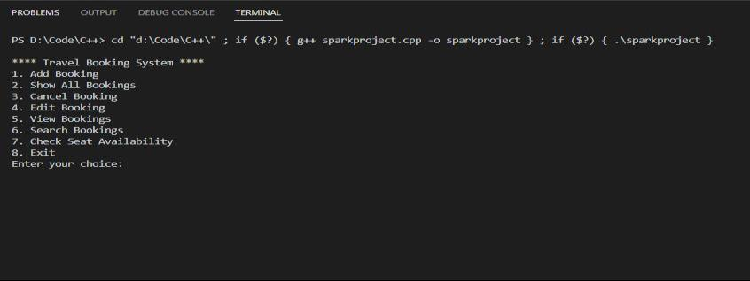

• Simple switch –case used to map choice to destination

• Instead of typing city names, user just picks a number

Choosing Destination Easily

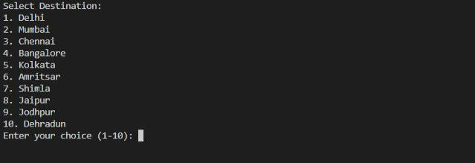

• Read/write with fstream (ifstream/ofstream)

• Edit/Delete using temp.txt as intermediate file

• Bookings stored in bookings.txt

File Handling



BookingID, Name, Phone Number, Age, Destination, Seat No.

Order of Data :

• 3, Gracy Mathur,8764332399, 18 , Delhi, 14

• 2, Priyank Mundel,9351179474, 19 , Jodhpur , 13

• 1, Harshita Parsendiya, 8234978234, 18 , Jaipur, 12

Sample Booking Data



Screenshot Sample Booking Data

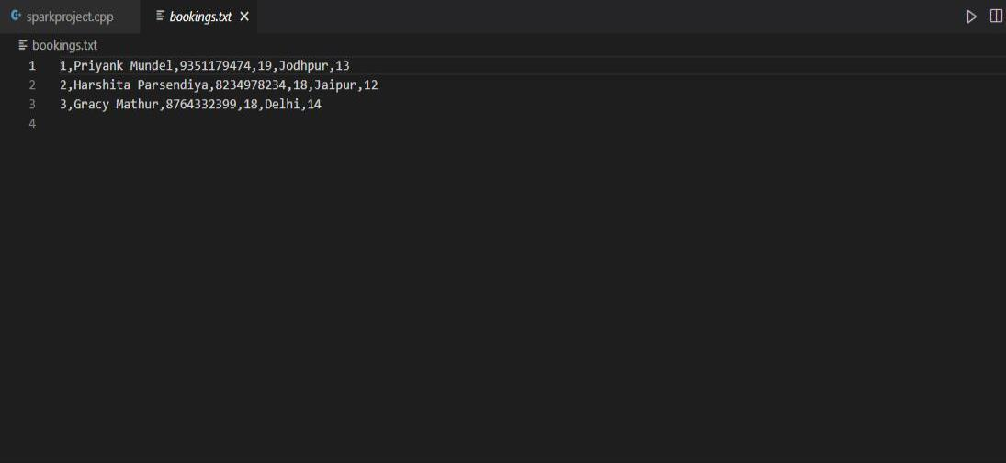

➢How to make a simple real world system

➢File Input/Output in C++

➢Input Validation

➢Classes and Objects

• This project helped us learn :

Conclusion



https://github.com/Priyankm05/Travel-Booking-System

GitHub Submission

